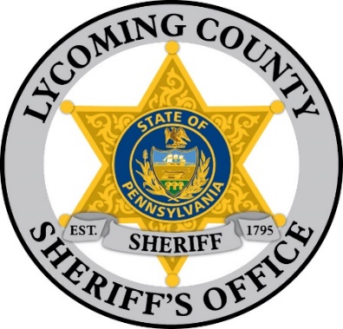
COUNTY OF LYCOMING
Eric Spiegel, Sheriff
Lycoming County Courthouse
48 West Third Street
Williamsport, Pa 17701-6536
Phone: (570) 327-2280
Fax: (570) 327-2366
www.lyco.org
Keely Mahosky Chief Deputy
kmahosky@lyco.org

Michele McDermott Office Manager
mmcdermott@lyco.org

PRECIOUS METALS DEALER APPLICATION – BUSINESS
Applicant Information License # Issued: _______________
Applicant Full Name: |  |  |  | Date of Birth: _ /_ _/_ _ Age: Sex:
Previous Name or Aliases: |  |  |  | Phone:  Driver’s License Number:
Current Address:

Applicants Current Email:
Business Information
Business Operating Name: |  |  |  |  | Business Phone:
If Assumer or Fictitious Name, Date of Registration of Same:
Owners Name:
Owners Business Address:
PA Corporations: Date of Incorporation: _ /_ _/_ _ Municipality:
Foreign Corporations: Date of Registration in PA: _ /_ _/_ _ State Incorporated:
Date of Incorporation: _ /_ _/_ _
NAME & ALIASES OF PARTNERS OR OFFICERS & BOARD MEMBERS | TITLE | ADDRESS |  |  |  | PHONE
Office Manager
(REQUIRED)
Have any of the above-named Partners, Corporate officers, or Members of the Corporation’s Board of Directors ever been indicted or convicted of a crime in the Commonwealth or elsewhere? YES NO  If yes, give details: |  |  | Have any of the above-named Partners, Corporate officers, or Members of the Corporation’s Board of Directors ever had an application rejected or a Precious Metals Dealer License suspended, cancelled or revoked by a Federal, State or Municipal authority? YES NO  If yes, give details:
I hereby certify that the statements contained herein are true and correct to the best of my knowledge and belief. I understand that if I knowingly make any false statements herein, I am subject to penalties prescribed by law. I authorize the Sheriff, or his designee, to inspect only those records or documents relevant to information required for this application. This certification is made subject to the penalties of section 4904 of the Crimes Code (18 Pa.C.S. 4904) relating to unsworn falsifications to authorities.
Signature: Date: _ /_ _/_ _

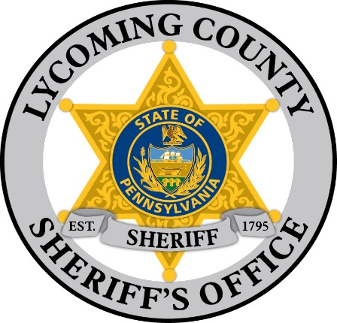

Keely Mahosky Chief Deputy
kmahosky@lyco.org

Michele McDermott Office Manager
mmcdermott@lyco.org
COUNTY OF LYCOMING
Eric Spiegel, Sheriff
Lycoming County Courthouse
48 West Third Street
Williamsport, Pa 17701-6536
Phone: (570) 327-2280
Fax: (570) 327-2366
www.lyco.org

PRECIOUS METALS DEALER APPLICATION – INDIVIDUAL

Applicant Information License # Issued: _______________
Applicant Full Name: |  | Date of Birth: _ /_ _/_ _ Age: Sex:
Previous Name or Aliases: |  | Phone:  Driver’s License Number:
Current Address:
Municipality:
Applicants Current Email:
Name Business will be operating under:
APPLICANTS PREVIOUS RESIDENCES FOR THE LAST 5 YEARS
COMPLETE ADDRESS YEARS
1.
2.
3.
Applicant’s Employer: |  |  | Employer Phone:
Employer Address:

Have you been indicated or convicted of a crime in the Commonwealth or PA or elsewhere? YES NO  If yes, give details: | Have you ever had an application rejected or a Precious Metals Dealer License suspended, cancelled or revoked by a Federal, State or Municipal authority? YES NO  If yes, give details:
I hereby certify that the statements contained herein are true and correct to the best of my knowledge and belief. I understand that if I knowingly make any false statements herein, I am subject to penalties prescribed by law. I authorize the Sheriff, or his designee, to inspect only those records or documents relevant to information required for this application. This certification is made subject to the penalties of section 4904 of the Crimes Code (18 Pa.C.S. 4904) relating to unsworn falsifications to authorities.
Signature: Date: _ /_ _/_ _

